Appendix 1: Assignment submission cover sheet
ASSIGNMENT SUBMISSION COVER SHEET

Cse24-124
Student Id:

Karabo Leetile
Student names:
Cse24-124@thuto.bac.ac.bw
Student email:

2025
Cohort:

CSE202 – INTRODUCTION TO OBJECT ORIENTED ANALYSIS WITH JAVA
Assignment title:

19 September 2025
Computer Systems Engineering
Date of submission:

Programme of Study:

Year 1
Year of Study:

Intellectual property statement
By checking the box below, I certify that this assignment is my own work and is free from plagiarism. I understand that the assignment may be checked for plagiarism by electronic or other means and may be transferred and stored in a database for the purposes of data-matching to help detect plagiarism. The assignment has not previously been submitted for assessment in any other unit or to any other institution.I have read and understood the Botswana Accountancy College plagiarism guidelines policy.


☐ Agree Signature…………………………………….

Part A: System Documentation
1.1.Functional Requirments
1.What is the minimum balance required for each type
A minimum of 500 is necessary to open an account.

2. Are there any withdrawal limits
For savings its 50 and investment its 500 as for cheque its 0.

3.what are the requirements for opening an account
In terms of the restrictions and stuff like that, I think those ones are farfetched for this assignment.

4.How is interest calculated
For individual the rate for savings to be 0.025. Savings for company customer should be 0.075. Monthly.

5.Should a customer be able to transfer funds within accounts
Well, that feature really isn’t in the question paper and isn’t necessary

1.2.Non functional Requirments
1.What are the security requirements
we expect somebody to be able to log in, user authentication is already articulated there

2.What happens after failed login attempts
Such features don’t need to be focused on over others

3.should the system support multiple bank users at the same time
In terms of performance, like you're saying, then we are going to have to deal with distribution, allowing people, different people to log in at different times.

4.What currency should it support
You can dictate in terms of the currency they want to use, whether it's a pula or any denomination, it doesn't matter

5.Should a custome be able to view transaction history
They should be able to open and view the transaction history of any account they hold and the transaction history we expect to see the date in which the transaction was done.
2 Structual UML Modelling
2.1.System case diagram
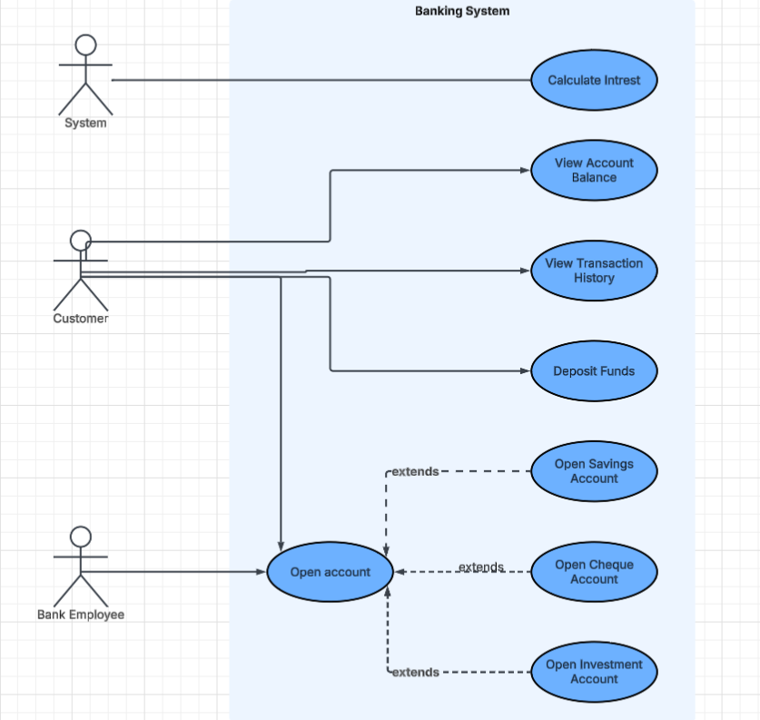

2.2 Class Diagram
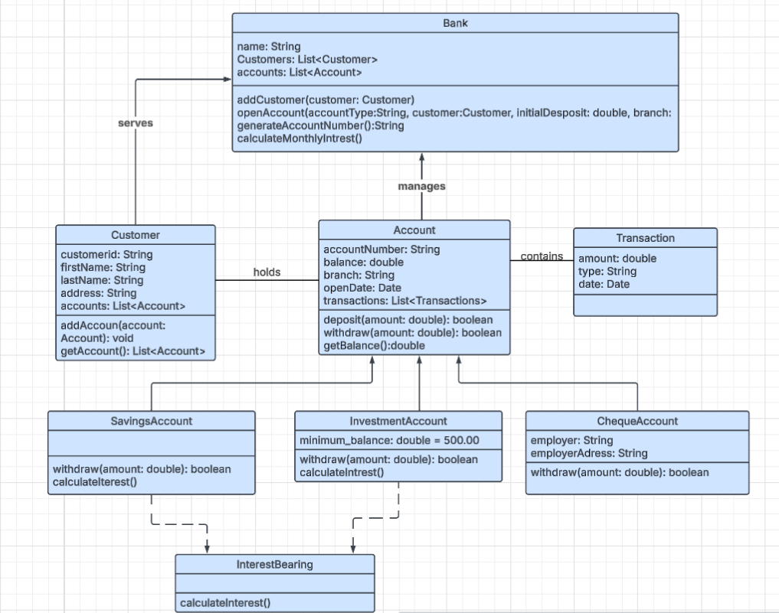

3.Behavioural UML Modelling

3.1.Login and Deposit Sequence Diagrams:
Deposit:
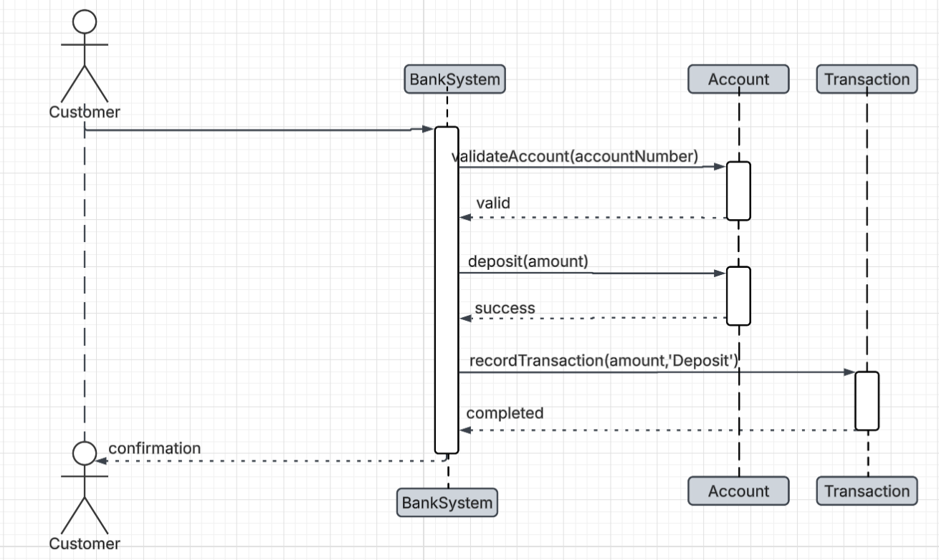

Login:
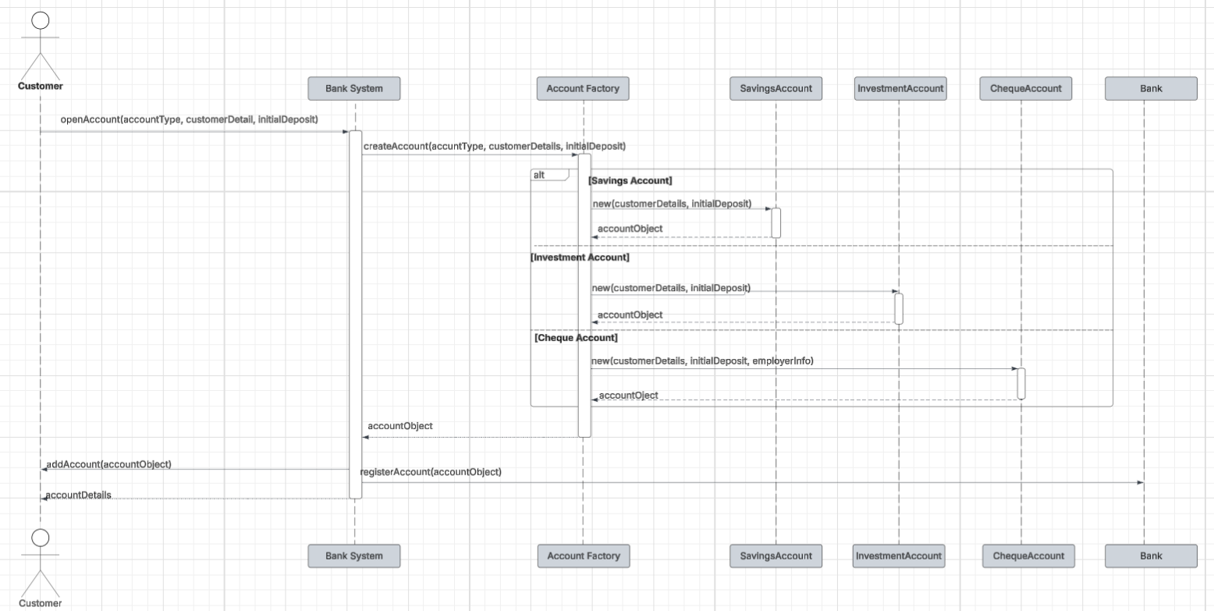

3.2.State Diagram:
